Access Statement for the National Maritime Museum

Introduction to The National Maritime Museum

Contact Information

Getting to the Museum:
Planning your visit (including accessible travel and parking)

Getting Around the Museum:
Museum entrances
Visitor Resources and general information
Lifts and stairs
Museum Spaces (including galleries, cafés and shops)
Toilets (including Changing Places)

Please note all information contained within this document is accurate on 01/01/2024

An introduction to The National Maritime Museum

The National Maritime Museum is the world’s largest maritime museum, with free galleries and a vast collection that spans artworks, maps and charts, memorabilia, and thousands of objects. Located within a UNESCO World Heritage Site, the museum is in the centre of Maritime Greenwich, where you can spend a whole day discovering the stories of exploration that shaped the world we live in today. Highlights include the actual uniform Vice Admiral Nelson was wearing when he was fatally wounded at the Battle of Trafalgar, stories of Polar and Pacific exploration, and our collection of figureheads and ships badges.

As part of the Dementia Inclusive Greenwich Network group DING, we are a dementia-inclusive site. We are a welcoming space and a community hub. We work with and welcome a diverse range of communities. We aim to celebrate difference, champion equality, and highlight hidden histories. We have regular sessions for children with Special Educational Needs called SENsory Sailors as well as monthly Adult SEND sessions. See the Royal Museums Greenwich website for dates of these.

We run several festivals throughout the year, celebrating our communities. These often include loud music and are some of our busiest days. We would love to welcome you to one of our festivals, but we understand if this type of environment isn’t everyone’s cup of tea so, please check our What’s On page for upcoming events when planning your visit. We have ear defenders available should you wish to borrow them on a festival day or any other!

Please download the Smartify app before visiting to access a free audio tour of the National Maritime Museum. You’ll spot the numbers around the site as you visit. You can also use this to access our Freedom Fighters trail in Atlantic Worlds. All of our English-language Smartify tours have BSL and subtitles included.

For families, we have an exciting accessible playground, The Cove, within our grounds on the park side of the museum. Young adventurers can enjoy exploring this with their adults. The Cove closes at 15:30 in the winter and 16:45 in the summer. Throughout the museum are Play activations; these are toys and dress-up pieces in the galleries and open spaces for visitors young and old to play with while visiting. Other dedicated play spaces include the All Hands gallery and Ahoy! gallery. To manage demand, Ahoy! is charged and ticketed during weekends and school holidays, but free on weekdays during term time. Colouring in sheets are available in the All Hands gallery and Voyagers gallery.

Contact Information

Our Bookings office is open 9am-5pm, Monday-Sunday. The office and the museum is closed 24th- 26th December each year.

Telephone: +44 (0)20 8312 6608 | Email: bookings@rmg.co.uk
National Maritime Museum, Greenwich, London SE10 9NF

If you want to know more about what to expect when visiting, please check out our Visual Story guide which provides pictures and descriptions explaining in more detail what it’s like at the Museum.

This guide can be found on our access page on the RMG website and can be especially helpful for anyone who appreciates some extra preparation when going on an adventure.

You can download a sensory map from our website:
https://www.rimg.co.uk/plan-your-visit/facilities-access

Getting to the Museum

Planning your Visit

Accessible Bus Travel
Please check websites prior to visiting for up to date travel information.

Frequent bus routes operate around Greenwich. The nearest bus stop is on Romney Road and comes up on the bus route as Stop G/Stop F: National Maritime Museum

Buses come regularly from:

Central London
188 – This bus stops at Surrey Quays, Canada Water, Elephant and Castle, Waterloo, Holborn, Russell Square, North Greenwich

East London
177 – This bus stops at Deptford Bridge, New Cross and Peckham
180 – This bus stops at Lewisham Station and Shopping Centre

North Greenwich (Emirates Cable Car, Jubilee line and the O2 arena)

129 – This bus stops at Ikea and travels through East Greenwich

188 – Trafalgar Road, Tyler Street, North Greenwich

Blackheath
286 – This bus stops at Blackheath, Eltham, Queen Mary’s Hospital
386 – This bus stops at Blackheath

Additional help to plan a journey can be found at www.tfl.gov.uk

From the Romney Road bus stop it is 150 metres (0.09 miles) to the museum’s Romney Road Entrance or 373 metres (0.23 miles) to the Parkside Entrance next to Greenwich Park.

Please be aware if visiting via bus you may need to cross Romney Road to enter the museum, depending which direction you have traveled from.

There is a pelican crossing 40 metres (0.02 miles) from the museum gates.

If returning to Central London via bus, there is a covered bus shelter with a small amount of seating. Check the TFL website for accessibility information about buses to and from Greenwich, plus information on special services such as Dial-a-Ride and Taxicard.

Accessible DLR travel
Cutty Sark DLR station has step-free access. Please see Tube map on www.tfl.gov.uk for further information.

The nearest station is Cutty Sark which is 500 metres (0.31 miles) away from the museum.

Please be aware you will need to cross roads to get to the DLR station from the Museum. There are several pelican crossings in Greenwich town centre to facilitate safe crossing.

Accessible Rail travel
The SouthEastern line has trains running approximately every 10 minutes to London Cannon Street via London Bridge.

The line serves Maze Hill station which is 700 metres (0.43 miles) from the museum. For further Access information about Maze Hill please visit http:// www.nationalrail.co.uk/stations_destinations/MZH.aspx

Greenwich Station in Greenwich town centre is 700 metres (0.43 miles) from the museum. For further access information about Greenwich station please visit http://www.nationalrail.co.uk/stations_destinations/GNW.aspx

Greenwich and Maze Hill rail station platforms have step-free access via ramp, lifts or underpass. The ticket offices and car parks at these stations are also step free.

Please be aware you will need to cross roads to get to the station(s) from the Museum. There are several pelican crossings in Greenwich town centre to facilitate crossing and a zebra crossing if coming from Maze Hill.

Accessible River Travel
Greenwich Pier is situated 500 metres (0.31 miles) from the museum. Clippers from Greenwich Pier come approximately every 20 minutes. Uber Boat by Thames Clipper for Central London stop at:

Canary Wharf / London Bridge / Bankside / Blackfriars / Embankment / London Eye

Please see timetable for exact times at http://www.thamesclippers.com/

For a more leisurely view of the Thames, City Cruises leave from Greenwich Pier approximately every 30 minutes from 10.00–17.40. Please see http://www.citycruises.com/ for more information

When coming from the pier the route is mainly pedestrianised but you will need to cross Romney Road before getting to the museum. There is a pelican crossing 40 metres (0.02 miles) from the Museum Gates.

Accessible Bicycle Travel
The National Maritime Museum is situated on Romney Road, postcode SE10 9NF. Bike racks can be found on the North side by the Romney Entrance and in the Car Park (see Car Park section below for directions)

Accessible Car Travel
The National Maritime Museum is situated on Romney Road, postcode SE10 9NF.

Car Park
The car park is open to the general public at weekends but Blue Badge holders may use the designated parking bays on any day of the week. Parking is free for Blue Badge holders. Please call our switchboard on 0208 858 4422 or e-mail bookings@rmg.co.uk to book

Limited pre-booked spaces are available and are payable via contactless payment at the car park entrance.

There are 6 designated Blue Badge parking bay(s) within the car park.

The dimensions of the designated parking bay(s) are 235cm x 490cm.

The nearest designated bay is 150 metres (0.09 miles) from the Romney Road Entrance of the National Maritime Museum.

The route from the car park to the entrance is accessible to a wheelchair user.

The car park is tarmac leading onto a gritted non-slip.

There are no roads to cross once inside the car park.

The car park does not have a height restriction barrier.

If you do not have a Blue Badge and wish to park on the weekends the price is £10. This can be paid online or at the booth in the car park.

The car park is in the open air on Park Row within the grounds of the museum, postcode SE10 9NF.

Getting Around the Museum

Entrance to the National Maritime Museum
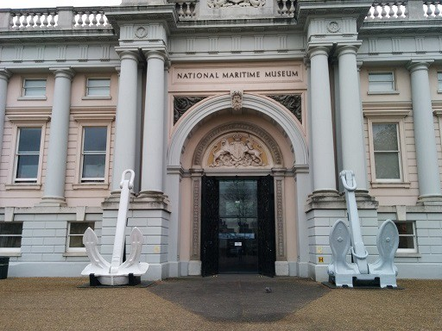
The Museum has two entrances: one at Romney Road and one on King William Walk leading into the park, called the Parkside Entrance.

Romney Road entrance

This entrance has step free access and automatic entrance doors The doorway measures 1m 65cm in width. The flooring at this Entrance is large scale tiling with a non-slip surface.

The lighting is dim blue ultraviolet spotlights.

This leads into the ticket area which has brighter white spotlights. The ticket desk at the entrance is 1m 8cm high. There are 5 display screens above the ticket desk.

A fixed induction loop is located on the ticket desk.

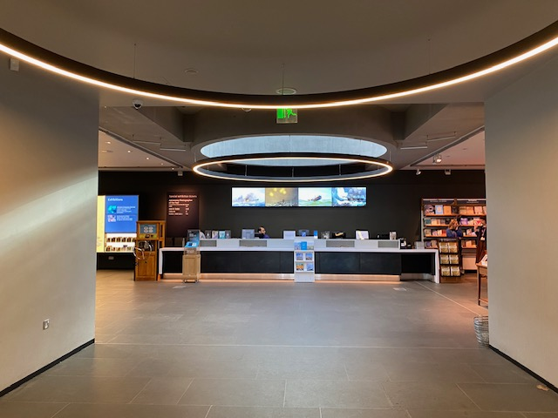
Romney Road entrance - inside

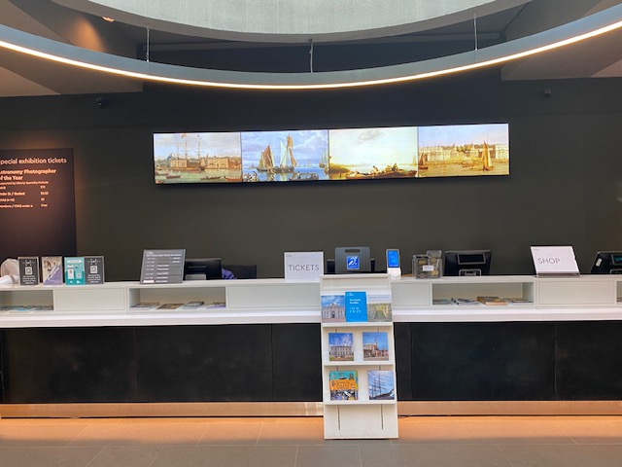
Romney Road Ticket desk

Parkside Entrance
Please note there is a moderate slope down to the Parkside Entrance.

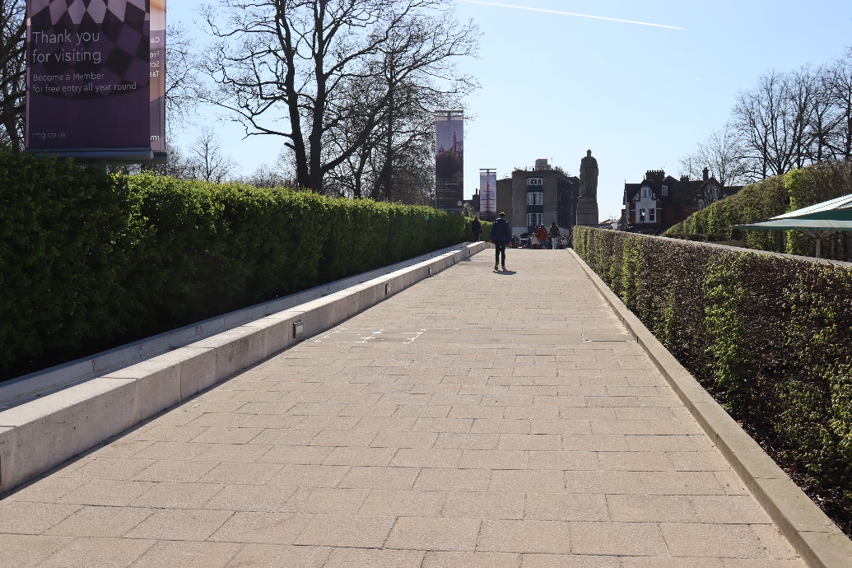
Level change before reaching the Parkside Entrance

The Parkside Entrance to the Sammy Ofer Wing has step free access and automatic entrance doors. The surface before entering is a combination of gritted, non-slip and concrete.

The doorway measures 1m 60cm in width at the Parkside Entrance.

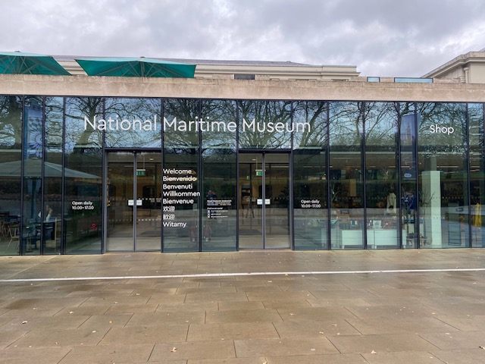
Parkside entrance

The flooring at the Parkside Entrance to the Sammy Ofer Wing is smooth, non-slip flooring.
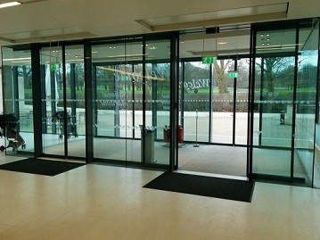
Parkside entrance

The lighting at the Parkside Entrance to the Sammy Ofer Wing is bright and is provided by natural light and spotlights.

The Information desk in the Sammy Ofer Wing is 78cm high.

A Fixed Induction loop is located on the ticket desk.

Parkside Information and Ticket desk
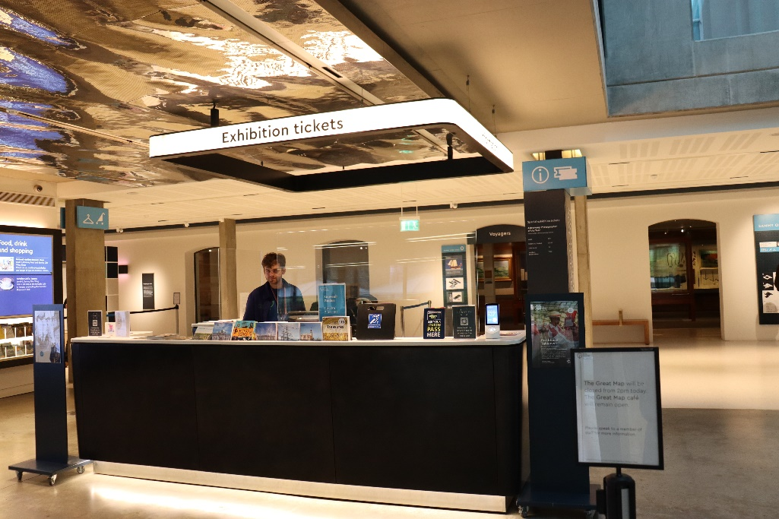
Wall mounted maps are available at both entrances for wayfinding.
Parkside Information and Ticket desk

Concessionary tickets
The museum and its permanent galleries are free to enter but some elements (such as Special Exhibitions and the Ahoy! Gallery) are ticketed.

To be eligible for a concessionary ticket rate, you must be a full-time student or under 25. Evidence can be proof of age documentation or a valid student ID.

Companions
We allow one companion entry into any special exhibitions which require a paid ticket to accompany those in need of assistance.

Assistance dogs – including Guide Dogs and Hearing Dogs - are welcome at the museum, as are accredited therapy / support dogs. Please contact our Bookings team in advance if you have any questions and please bring documentation with you on your visit where possible.

Additional Resources
We have a variety of resources available for visitors to use during their visit. Please ask any member of staff for assistance. Resources include:

Ear defenders
Sensory Explorer kits
Paper trails
Smartify tours
Magnifying Glasses
Large format guides for some galleries
Portable stools – these are available throughout the museum on the wall racks in the galleries / open spaces and do require advance booking

Wheelchairs – to book in advance please call +44 (0)20 8312 6608 and can also be booked on the day if they are available.

Please note that our wheelchairs cannot leave the museum, for example to take someone to the Royal Observatory.

Wheelchairs can be hired from the Discover Greenwich centre at the Old Royal Naval College in Greenwich for a small deposit which can be taken outside and around Greenwich.

There are free “Gallery Favourite” talks every day at 11:00, 13:00 and 15:00.

There are paid Treasure Tours every day at 12:00 and 14:00. Tickets can be purchased from the Parkside Information and Ticket desk.

All talks and tours are dependent on staff levels and could be cancelled at short notice.
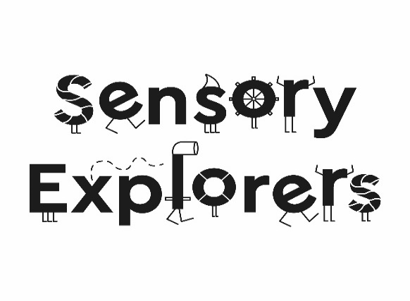

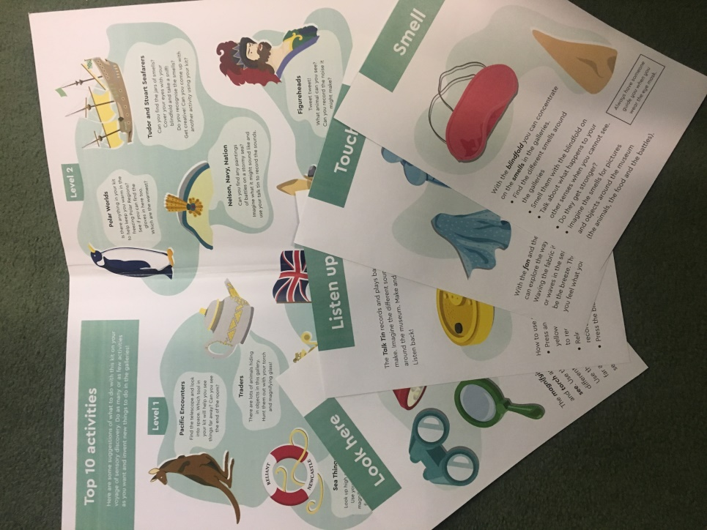
To support SEND (special educational needs) families in their visits to the NMM galleries we have developed a Sensory backpack for explorers to use while visiting us. We hope this enhances SEND family visits and helps you to engage with the Museum galleries. The bags provide a tactile, flexible, and hands on opportunity for families to engage with the collection. We encourage adults and children to explore together and share conversations.
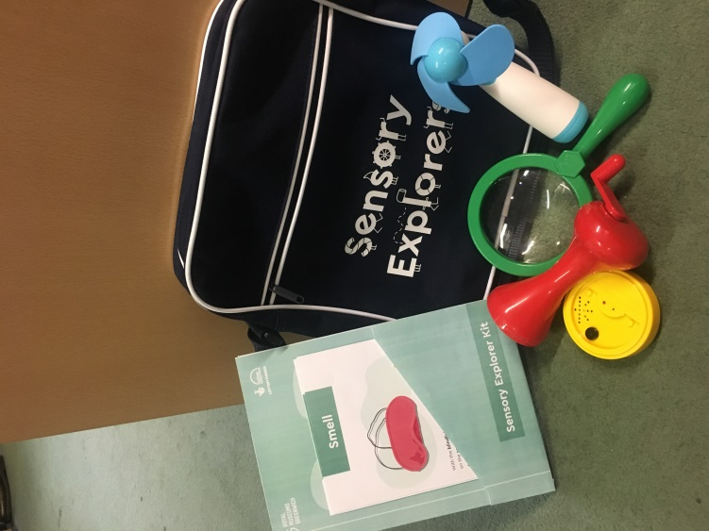
The backpack contains:
- Wind up torch
- Fabric
- Blindfold
- Handheld fan
- Talk tin
- Binoculars
- Magnifying glass
- Resources kit, including 4 senses cards

How is it used?
- Pick up from the ticket desk at the Romney Road entrance.
- Provide contact number and name (must be someone on the visit) in exchange for borrowing the bag.
- Resources kit provides ideas for each gallery as to how the kit can be used to explore. These are suggestions and not exhaustive.
- Return backpack to Romney Road Admissions desk when visit is complete.
- Your name and number slip will be handed back to you.

Please note that bag availability depends on the number lent out.

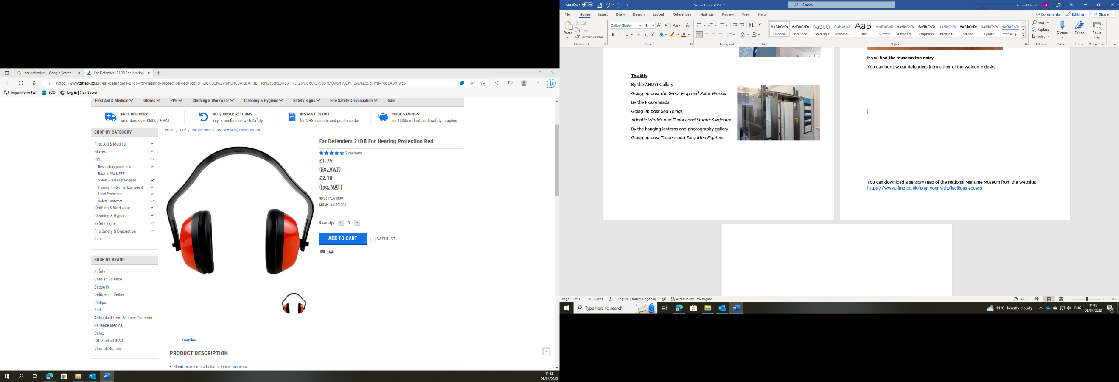

If you find the museum too noisy, particularly on our special event days, you can borrow ear defenders from our welcome desks. Large Print guides are available in some galleries.

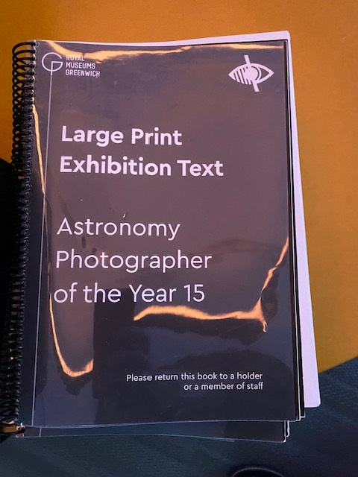
Large print guides are available in some galleries. Please ask any member of staff for assistance.

Lifts
The building has accessible lifts to every floor.

There are 3 lifts to reach the first and second floor and 1 lift to reach the Special Exhibition gallery in the Sammy Ofer Wing.

Outside the Museum there is a platform lift to access the colonnades.

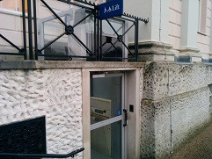
External Platform Lift on east side of museum

This lift has tactile buttons.

The door to exit the lift is on the left as you enter the lift.

The Caird lift
The Caird lift is in the blue ‘link’ corridor between the The Square and the Sammy Ofer Wing.

It can be used to reach Level 1 and 2 for the Traders, Atlantic Worlds, Forgotten Fighters and Nelson, Navy, Nation galleries, and the Caird Library.

The door opening is 1m 22cm wide. The interior dimensions are 2m 65cm long, 1m 60cm wide.

There is no mirror to aid reversing in a wheelchair.

The buttons are tactile.

There is a floor number display.

There is a beeping noise to indicate the lift reaching a floor level and the lift door opening.

The entry and exit doors are the same. (unless using the mezzanine level for access to the Caird Library where the doors open at the opposite end to entering).

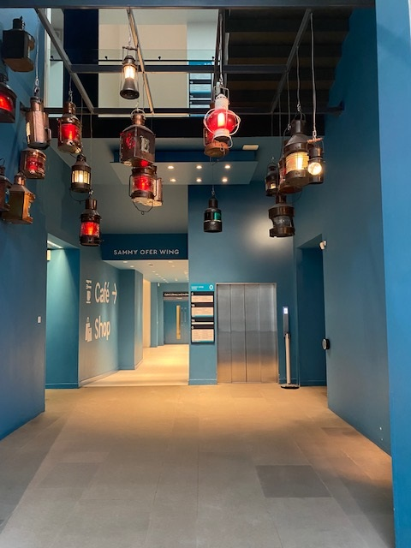
Caird Lift

The Stanhope lift
The Stanhope lift is the nearest lift to the Romney Road entrance. To access the lift on entering from the Romney Road Entrance turn left once inside the building, then left again down the corridor.

The lift can reach Level 1 and 2 for the Great Map, Member’s Room, Ship Simulator, Bridge and Polar Worlds gallery. It is next to the Stanhope stairs. This lift is made of see-through glass.
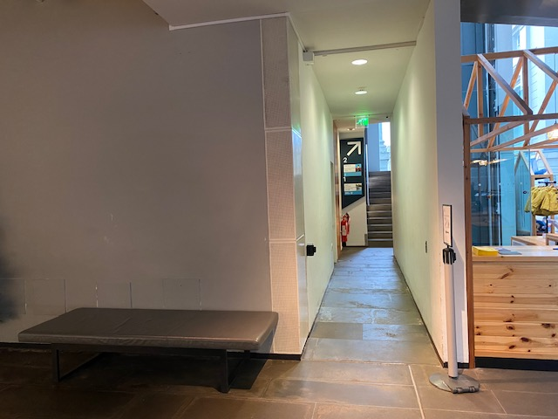
Corridor leading to the Stanhope Lift
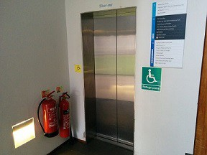
The Stanhope lift

The door opening is 83cm wide. The interior dimensions are 1m 90cm long by 1m 40cm wide. There is no mirror to aid reversing in a wheelchair. The buttons are tactile. There is a floor number display.
The entry and exit doors are the same.

The Lewin lift
The Lewin lift is located next to the Lewin staircase. It can be used to reach Level 1 and 2 for Sea Things, Baltic Glass display, the Great Map, Atlantic Worlds, Tudor and Stuart Seafarers and Nelson, Navy, Nation galleries.

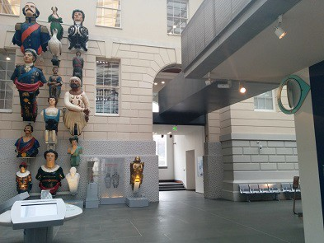
The lift is located through the archway in the south-east corner of The Square on Level 0.
Direction to Lewin lift and Stairs

This lift is made of see-through glass.
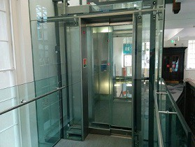
The Lewin lift

The door opening is 83cm wide. The interior dimensions are 2m long by 1m 34cm wide. There is no mirror to aid reversing in a wheelchair.

The buttons are tactile. There is a floor number display. There is an audio floor number indicator.

The entry and exit doors are both in front and behind depending on which floor you enter and leave.

The Special Exhibition Gallery lift
The Special Exhibition Gallery lift is used only to reach the Special Exhibitions Gallery on Level -1 in the Sammy Ofer Wing.

It can be used in an evacuation with the aid of a trained staff member.
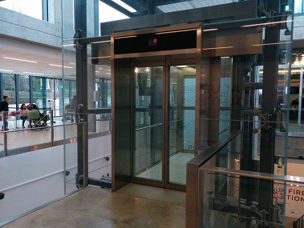
This lift is made of see-through glass.
The Special Exhibition Gallery lift

The door opening is 1m 29cm wide. The interior dimensions are 2m 75cm by 1m 58cm.

The buttons are tactile. There is a floor number display. Floor numbers and door opening/closing are announced by an automated voice system.

The entry and exit doors are at opposite ends of the lift.

The Terrace Cafe lift
This lift is to reach the Terrace Cafe only, which is located above the Sammy Ofer Wing. This lift is located down the corridor next to the Parkside Information and Ticket desk.

The door opening is 88cm wide. The interior dimensions are 1m 40cm long by 1m 8cm wide.

The buttons are tactile. There is a floor number display. Floor numbers and door opening/closing are announced by an automated voice system.

The entry and exit doors are the same. There is a mirror to aid reversing in a wheelchair.

Stairs
There are 7 staircases in the museum.

The Stanhope stairs
These stairs are the nearest stairs to the Romney Road Entrance. To access the stairs on entering the Romney Road Entrance turn left once inside the building, then turn down the corridor on the left (see directions for Stanhope lift above).

They can be used to reach Level 1 and 2 for the Great Map, Member’s Room, Ship Simulator, Bridge and Polar Worlds gallery.

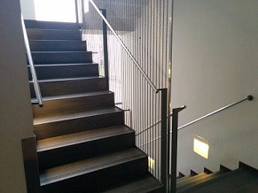
The Stanhope staircase

The stairs have closed steps. The steps are 20cm high and 30cm deep. There are landing areas which can be used as rest areas if needed. There are 44 steps in total.

The Lewin stairs
The stairs located through the archway in the south-east corner of The Square on Level 0 (see directions for the Lewin Lift above). They can be used to reach Level 1 and 2 for Sea Things, Baltic Glass display, the Great Map, Atlantic Worlds, Tudor and Stuart Seafarers and Nelson, Navy, Nation galleries.

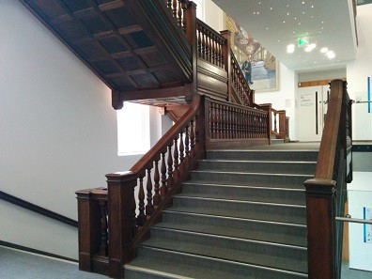
The Lewin staircase

The stairs have closed steps. The stairs are 18cm high and 30cm deep. There are 51 steps in total.

The Caird Library stairs
These stairs are located next to the Voyagers gallery in the Sammy Ofer Wing. They can be used to reach the Caird Library on Level 1.
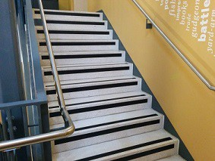
The Caird Library stairs

The stairs have closed steps. The stairs are 18cm high and 20cm deep.
There are 23 steps in total.
The Link stairs
It is possible to get from the Library on Level 1 to the Atlantic Worlds, Traders and Nelson, Navy, Nation galleries. The door on the left as you come up the Library stairs leads to a small rest area with a bench.

There are then 3 steps to get the Atlantic Worlds and Traders galleries. These steps are 18cm high and 26cm deep.

From this level there is another staircase to get to Level 2 and the Nelson, Navy, Nation and Forgotten Fighters galleries.

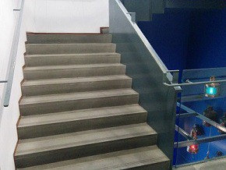
The Link stairs

These stairs are 18cm high and 26cm deep. There are 21 steps in total.
The stairs have closed steps.

Special Exhibition Gallery stairs
These stairs are for accessing the Special Exhibition Gallery on Level -1 only.

The stairs lead down from the Sammy Ofer Wing to the Special Exhibition foyer and gallery. They are next to the lift.

The steps are 17cm high and 34cm deep There are 36 steps in total.
The stairs have closed steps.

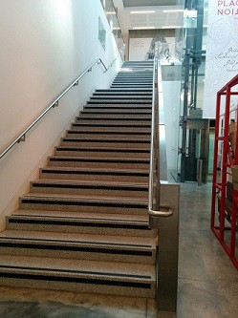
The Special Exhibition Gallery stairs

The Great Map stairs
There are two staircases leading directly to the Great Map from Level 0. These are located on the east and west sides of the Great Map.

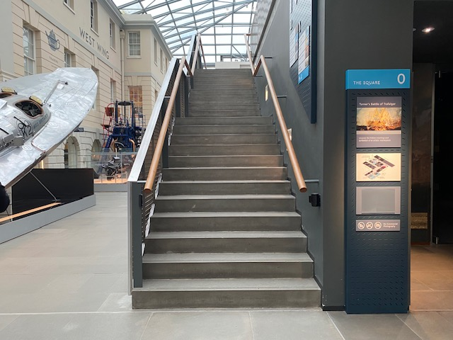
Stairs leading to the Great Map from West Street
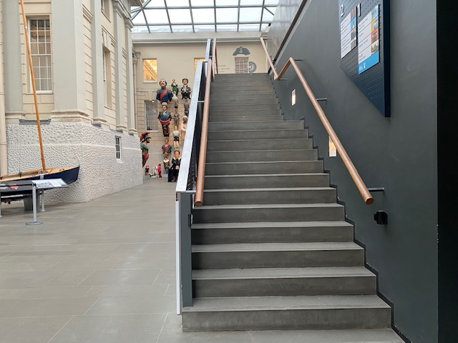
Stairs leading to the Great Map from East Street

The stairs can be used to reach the Great Map on Level 1 and the Great Map Café. The steps are 18cm high and 26cm deep. There are 23 steps in total. These stairs have closed steps.

The Terrace Cafe stairs
These are stairs to reach the Terrace Café only, which is located above the Sammy Ofer Wing. The stairs are located next to the Parkside café. The steps are 17cm high and 32cm deep. There are 23 steps in total.
The stairs have closed steps.

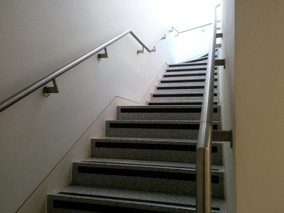
The Brasserie Stairs

National Maritime Museum galleries and spaces

Level 0

Ahoy!
Ahoy! Is a children’s gallery for children aged 0 – 7. The gallery is very interactive. It has wide spaces and sensory areas. The only areas in this gallery inaccessible to a wheelchair is the main deck of the Rawalpindi.

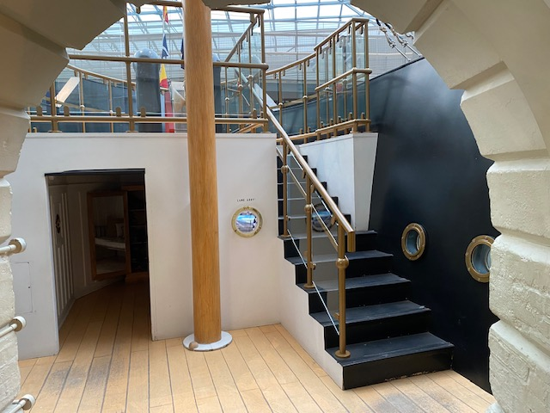
Stairs leading to main deck of Rawalpindi

There are also 4 small steps up to the beach hut / shop area.
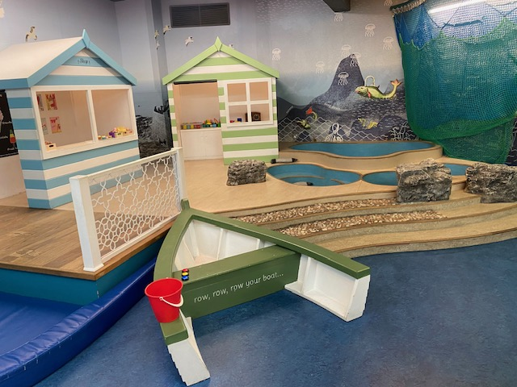
Steps up to Beach hut / shop area

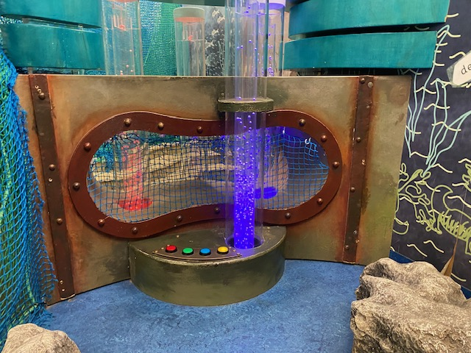
Ahoy! sensory area – no door, entry through an open arch
Astronomy Photographer of the Year
This is an annual exhibition that changes each year. It is usually closed in the second half of August while the display is changed. There are large print guides within the gallery. The images are displayed on light boxes starting at a height of 72cm, with others directly above. There are 3 circular wood benches, with 2 backed seats on each.

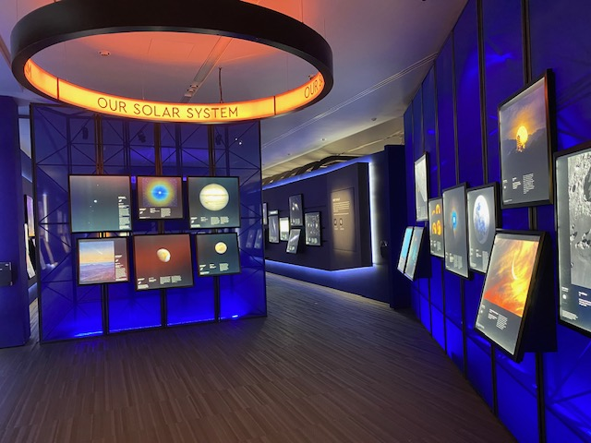
Astronomy Photographer of the Year gallery

In its current form, there is one large screen in the gallery that plays videos with visual, audio, subtitles and a BSL interpreter. The videos play when one of the 3 sensors are activated by waving. The sensors are 75cm high from the ground.
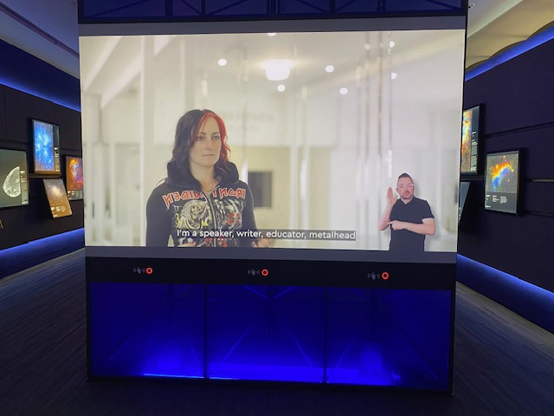
Astronomy Photographer of the Year video screen

The exit from the gallery is through swinging manual gates. No door to enter.

Voyagers
Voyagers is an introduction to the museum’s themes for those entering via the Parkside entrance. It has audio visual screens on the pillars with talking heads at a height of 118cm to 140cm from the ground. They do not all play audio. The ones that do not play audio will have a symbol underneath of an ear with a line through. All videos have the text displayed.

In this gallery is a ‘Play with me’ trolley. Visitors are welcome to relax, play, colour in and read or just take refuge from the outside weather. There is lots of seating, most of this is soft. There are 2 metal benches. There are display cases along the back of the gallery with the display area 76cm from the ground and three display cases in the central area, with display heights starting at 82cm, 86cm and 90cm. There are 3 open archways, any of which can be used to enter the gallery.

Please note that most of our galleries have low level lighting to protect the objects.

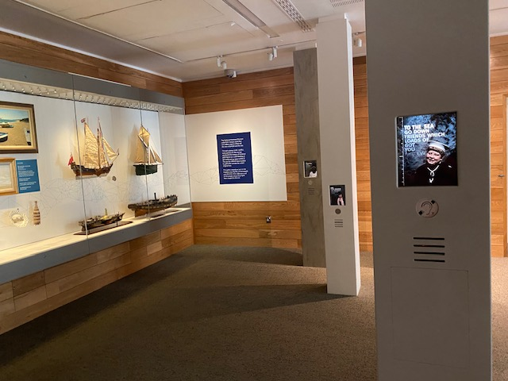
Voyagers Gallery talking heads.

Maritime London

This gallery explores London as a Maritime city, linked by the River Thames to the sea and the trade that this allowed for.

Maritime London is a quiet gallery with no sound or audio. It has wide open spaces and a central circular panorama of London and the River Thames, with markers for points of interest such as The Tower of London and St. Paul’s Cathedral. This circular space can be entered.

The gallery has large display cases with displays visible from close to ground level. There is a large bell which can be touched. This is displayed next to a piece of modern art.

The gallery has one exit /entrance with automatic doors. There is seating within the gallery.

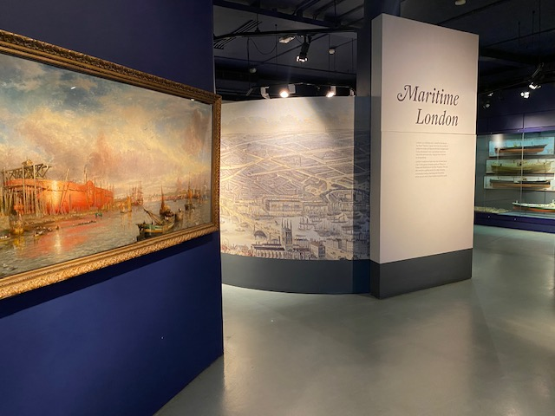

Maritime London gallery

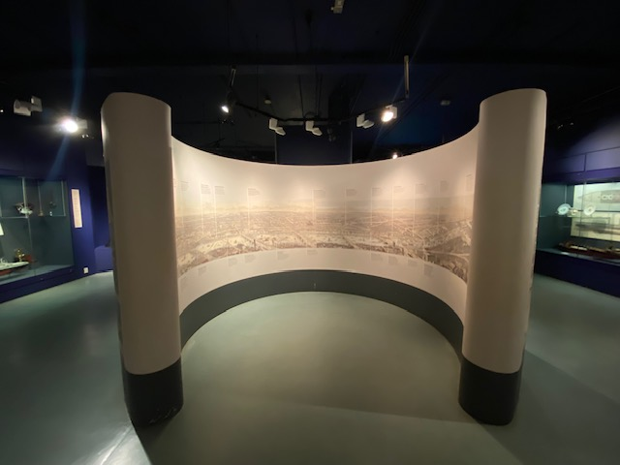

Maritime London gallery – circular space

New Insights Gallery – currently ‘Our Connection to Water’

This is a temporary exhibition space, currently housing a contemporary art exhibition about our connection to water.

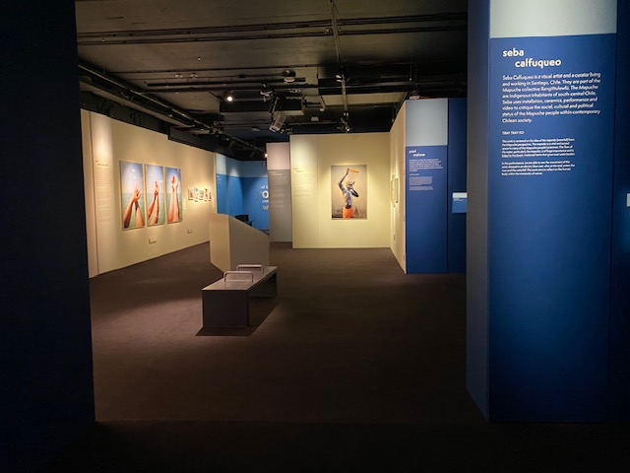

New Insights Gallery – current configuration

In its current iteration there is a wide-open main room with two alcoves off the main room. Within the main room is a video screen called ‘Conversations with our Grandmothers’, with an earpiece 100cm from the ground that can be used to listen to the audio. There is also a touch screen option for English subtitles, English subtitles with BSL or Chinese subtitles.

In the main room there is a projection on corrugated roofing sheets. There is a bench opposite this piece.

In one of the alcoves is a photographic display as well as Digital Sound entitled ‘Te Po’ which lasts for 4 minutes and 24 seconds. These are underwater sounds, from Sardinia, Norway and Cyprus and Whale sounds.

In the other alcove is a 6 minute film performance called TRAY TRAY KO. There is the sound of rushing water and metal jingling featured in the film with text at the end. The corridor leading to this space is dark. There is seating in the cinema-like space. There is seating at the south end of the gallery also, by the comment section where visitors are invited to tell us on paper what water means to you.

There are automatic doors at each end of the gallery. The north doors have a push button on each side of the door to control them.

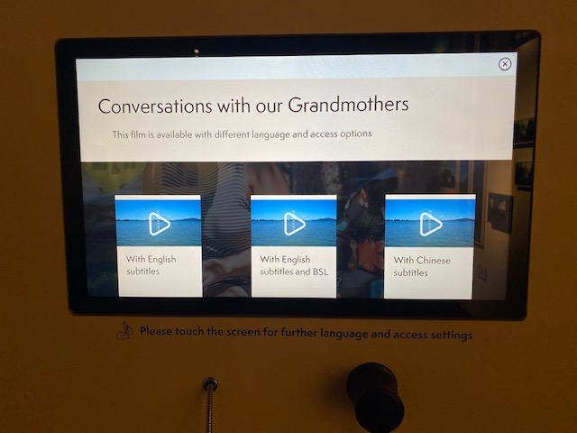

New Insights Gallery - subtitle and BSL options touchscreen and earpiece

Icons Gallery – currently Turner’s Battle of Trafalgar

This is a small, dark room but with a wide-open space which displays JMW Turner’s Battle of Trafalgar painting. There is audio interpretation played in the room. This plays every 15 minutes, with background music. There is a screen to the right of the painting displaying BSL interpretation and subtitles. There is a bench facing the painting.

There is one display case in the room with the display visible from close to ground level.

There is one set of doors into and out of the space and these are automatic. 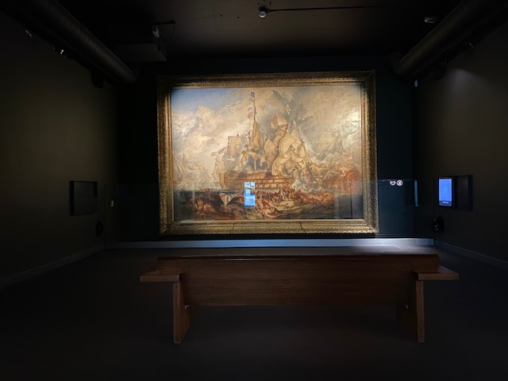

Icons Gallery: Turner’s Battle of Trafalgar painting

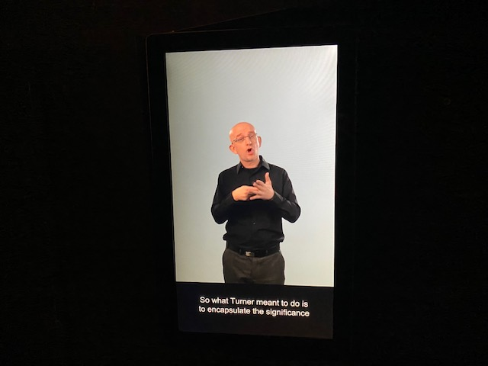

Icons Gallery: BSL interpretation with subtitles

The Square

The Square is the ground floor of the historic section of The National Maritime Museum. The floors are smooth and the ‘streets’ are wide.

The streets contain large objects such as Miss Britain III, the Reliant Engine and Prince Federick’s barge for you to enjoy. There is also a display of ship’s figureheads and the stern of HMS Implacable. Next to Miss Britain III and the Reliant Engine are touch screen videos with audio, subtitles and BSL interpretation.

Near the figure heads are some touch screens which can be used to learn more about the ship’s badges and figureheads. The Miss Britain III, the ship’s badges and ship’s figurehead screens are 89 cm from the ground. The Reliant screen is 123cm from the ground.

There are several cushioned benches along the ‘south’ street and some metal seating along the ‘north’ street near the toilets.

Along one side of Prince Federick’s barge is a ramp so visitors can have a different view of the barge. The interpretation along the ramp includes descriptions of the carvings and a gilded crown you can touch. This table is at a height of 75cm. There is also Handel’s Water music and sounds of the Thames playing, featuring the sounds of waves, seagulls and the hustle and bustle of the busy river front.

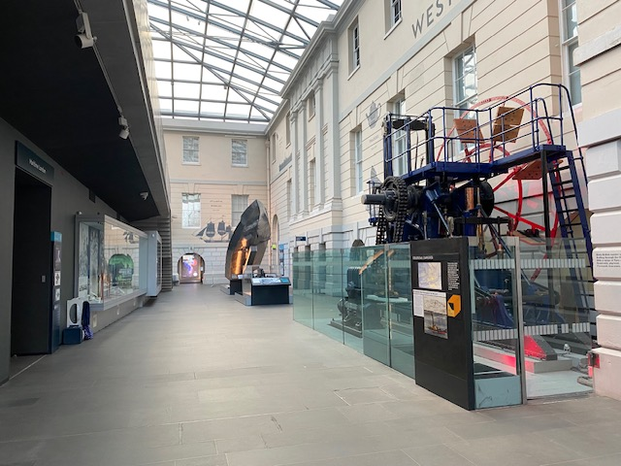

The Square: West Street

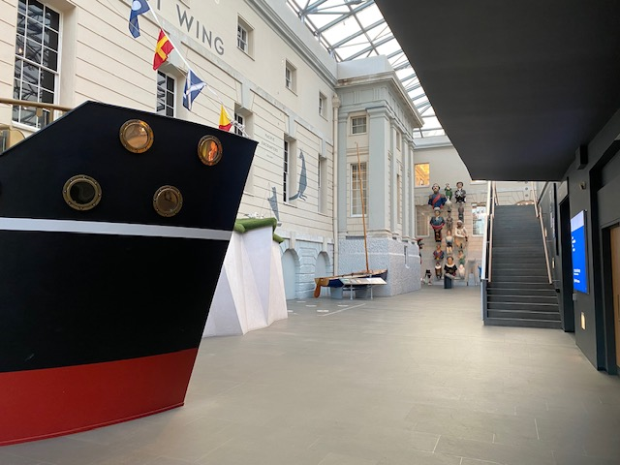
The Square: East Street

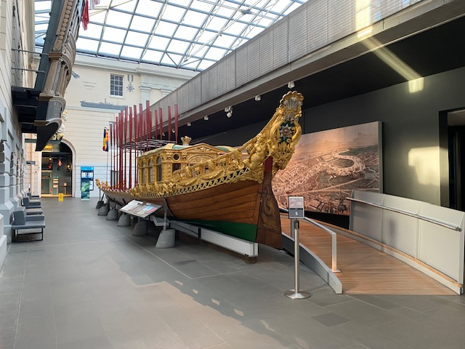

The Square: South Street

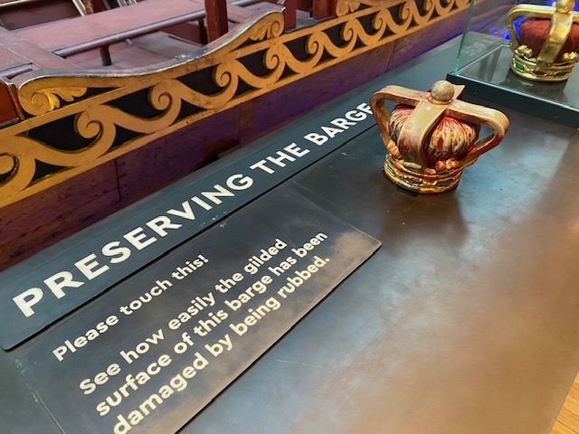
The Square: Prince Frederick’s barge interpretation

Level 1

Atlantic Worlds
One of the subjects Atlantic Worlds talks about is the history of the slave trade across the Atlantic in the 17th to 19th centuries. There is sensitive content displayed and these elements can be upsetting. If you need a quiet space or any assistance, please speak with a member of staff.
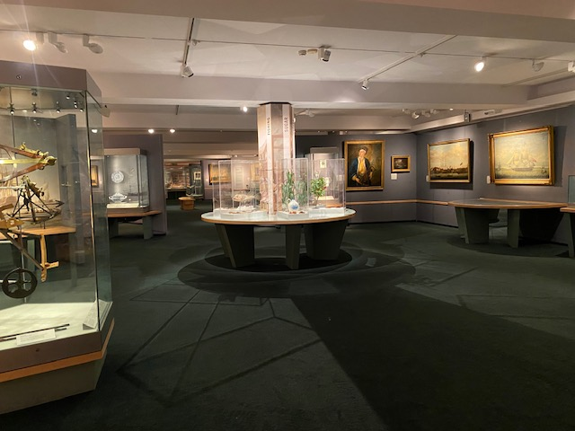
Atlantic Worlds gallery

There are wide aisles around the gallery. At the east end there is a table at 76cm height. There are display cabinets throughout the gallery. Some are displayed from close to ground level. Others height ranges from 66cm – 83cm. There are 2 sections with motion activated audio. One is in the ‘Trading & Settlement section and one is in the ‘Rebellion, War & Conflict’ section. There are 3 benches and manual doors to enter and exit the space.

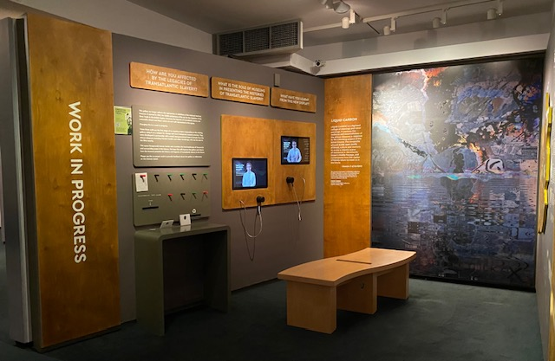Atlantic Worlds gallery – Work In Progress section
The Work In Progress section is an important addition to the gallery. There are 2 video screens with earpieces to listen from at 95cm and 113 cm height. There is a section for leaving feedback, desk is 81cm high. There is a free trail you can listen to on the Smartify app, called the Freedom Fighters trail (QR code can be found in the gallery).

Traders
Traders has two aisles, one central and one to the side. At the south end of the gallery there is a television screen with video, audio and subtitles called ‘Where is the East India Company today?’. Nearby, you can write your thoughts on the subject. The desk for this is 79cm height.

There are 5 interactive screens throughout the gallery, with desk height 70 cm and screen height 90cm. Paintings are hung at a range of heights from 86cm-108cm. Displays are visible from 71cm – 82cms height from the floor. There are several description panels at 61cm. Some of these invite you to look closer and explore the painting. There are 2 books with thick hard pages to look through. Near these, at the north end are Spice drawers at a height of 71cm, which you can open and smell the spices and a tactile flap. There are 2 canons in the gallery with embossing on, which can be touched.

At each end of the gallery are manual glass doors.

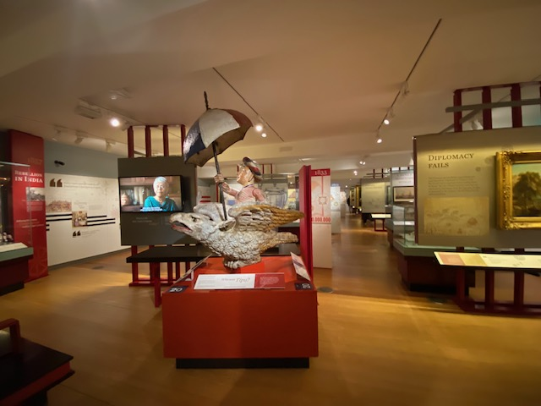
Traders gallery

The north end the gallery continues into a foyer. From the Traders gallery to the Great Map is a sloped bridge, slopping downwards.

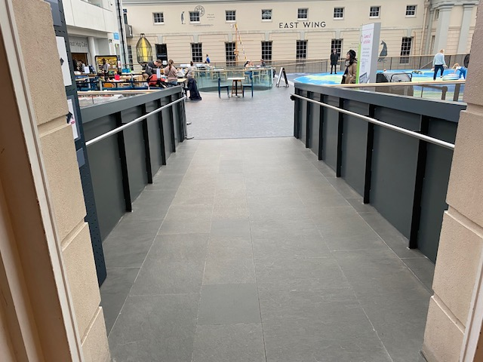
Traders gallery – sloped bridge to the Great Map
The Great Map
The Great Map is a large open space with a world map on the floor. There are replica ships for children to play with.

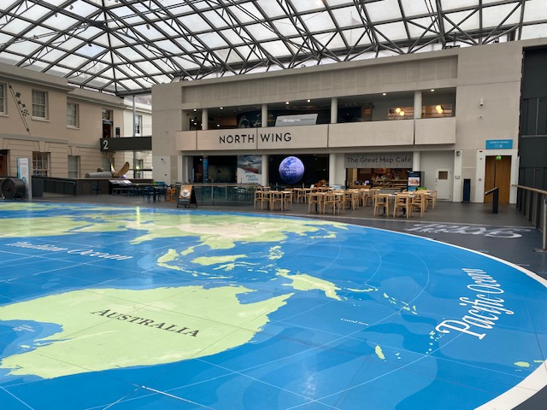
The Great Map

There are 2 interactive audio visuals on the Great Map with video, text and audio. They are 88cm high.

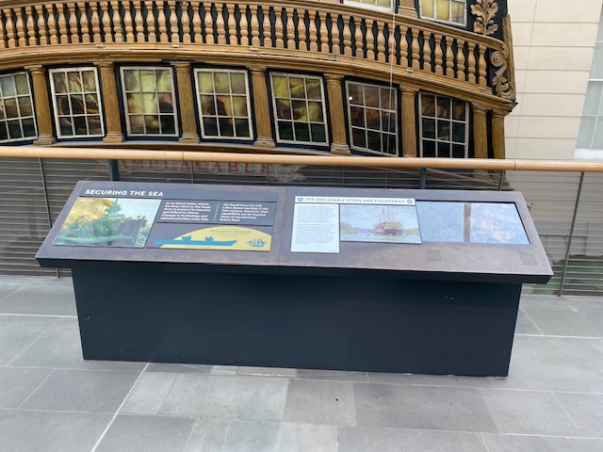
Great Map interactive panels

Poles Apart
Poles apart is an open space accessed via the north end of the Great Map. There is a large display case which is visible from near floor level.

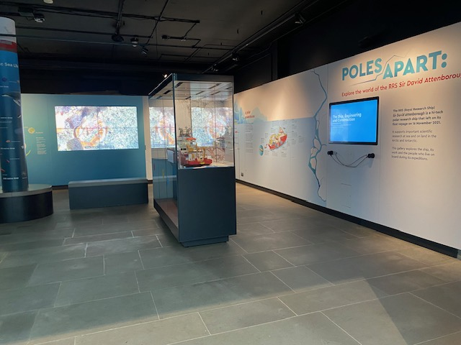
Poles Apart – display case

There are 2 screens that require ear pieces to listen to. These are at a height of 85cm for ‘What do the crew do?’, and 105cm ‘Ship, Engineering and Construction’.

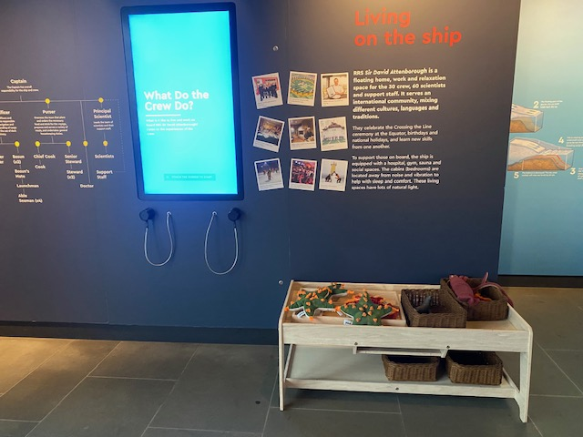
Poles Apart screen with audio ear pieces
There is a large screen about RRS Sir David Attenborough with video, audio and subtitles. It has a bench facing it.

Pacific Encounters
There are two points of access to the Pacific Encounters gallery. One is via automatic doors from the south end of the gallery (accessed via the Sea Things gallery) and the other is via a sloped bridge which slopes down from the Great Map to the gallery. This slope has several level changes in it and we advise taking your time when accessing the gallery from this point. There are railings along each side of the bridge.

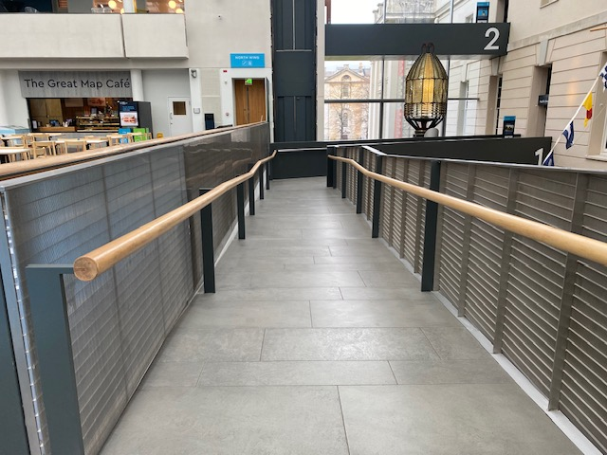
Great Map to Pacific Encounters sloped bridge, section 1

The slope flattens out part way down the first section, then again at the corner.

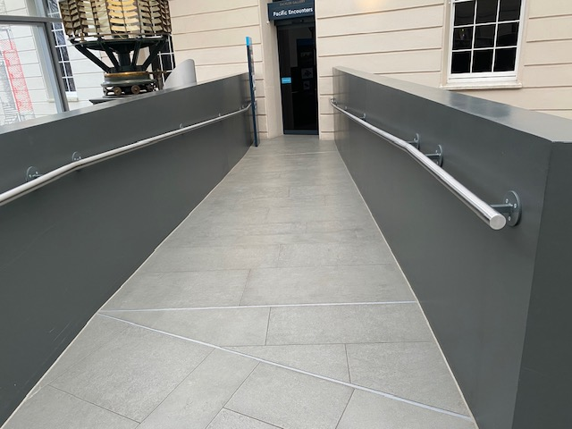
Great Map to Pacific Encounters sloped bridge, section 2
At each end of the Pacific Encounters gallery is a circular map at a height of 78cm at the south end and 93cm at north end. The north map has a set of 2 drawers in the cabinet. The drawers are quite heavy but pull out. Each contains a map. One is at 66cm and the other at 78cm.

Paintings are displayed at a range of heights starting at 55cm to above head height. Display cabinet heights range from 66cm – 78cm, and some from near floor level.

There are several tactile objects that can be touched. These are: a ship’s gun from the Endeavor (which has a raised emblem on), a statuette of Matthew Finders and cat, and a telescope. There is also a tactile interactive about the Mutiny on the Bounty at 85cm height.

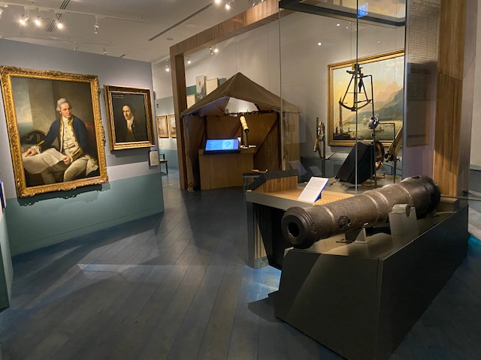
Pacific Encounters gallery

The Transit of Venus telescope is displayed at 125cm high, but the film can be seen from a seated distance, the button for the film is at 90cm. There is also a touch screen AV.
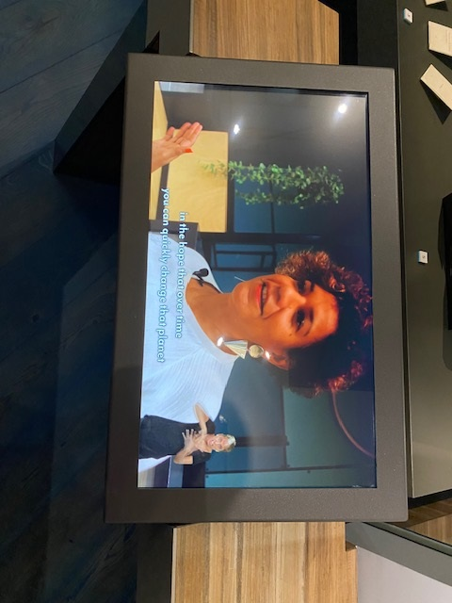
Pacific Encounters video screen BSL and subtitle interpretation

There are 5 touch screens throughout the gallery at 79cm high. 1 with video, audio, BSL and subtitles, as seen above; 3 with text and images, 1 map building game. On the South West wall is a wall mounted screen ‘Continuing Traditions’ showing a video with audio, subtitles and BSL. There are 4 benches in the gallery.

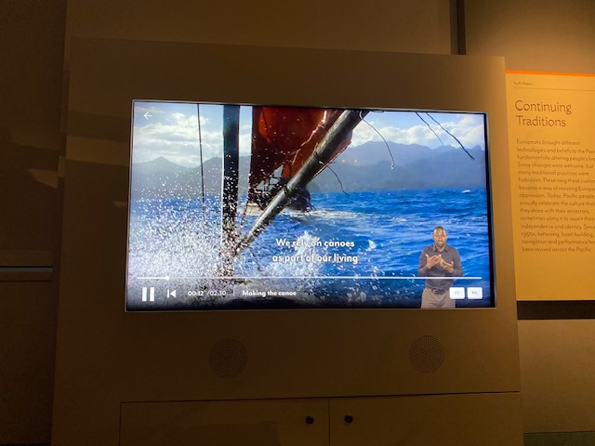
Pacific Encounters video screen with BSL and subtitle interpretation

There are 4 screens on the south-east wall displaying photographs. At each end of the gallery are glass automatic doors.

There is a ramp at the South door leading down to a stone floor in the rotunda area.

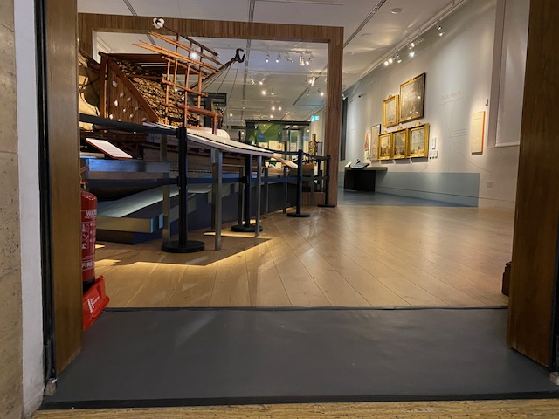
Pacific Encounters – south end entrance ramp

Sea Things
Sea Things is a space where lots of objects are available to touch! At the North end of the gallery are the sounds of the seaside. You will hear waves crashing and seabirds calling. There are 7 touch screens around the gallery to give you information about each object. They are 80cm from the floor.

There is also a touch screen at the same height ‘My memory is’. There are display blocks with visuals on that have objects to touch on. These range in height from 45cm – 90.5cm. The 2 glass display boxes are also at a display height of 90 cm. They also have lower display areas by floor level. Some objects are placed just above floor level for you to touch and there are lots of lift flap info panels.

At the South end of the gallery are busts, some modern (commissioned by RMG) and some older. Here, there are buttons to push that will play audio. These are at a height of 89cm from the floor.

There are ships badges panels on the wall. There is paper and pencils for you to create your own ships badges and display.
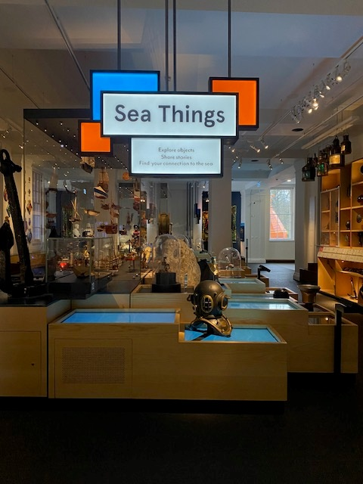
Sea Things gallery

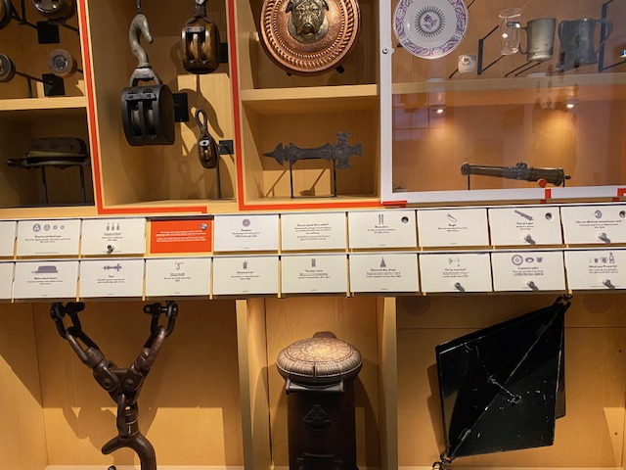
Sea Things: lift flap info panels and objects
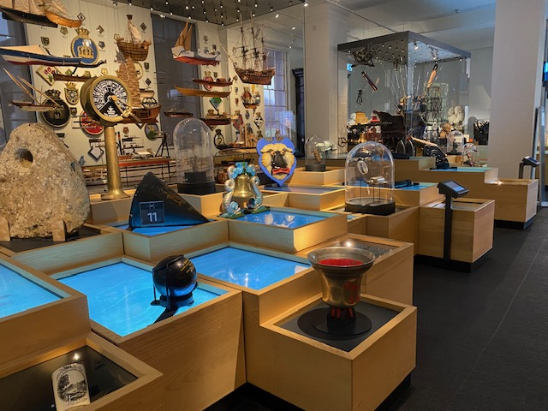
Sea Things gallery

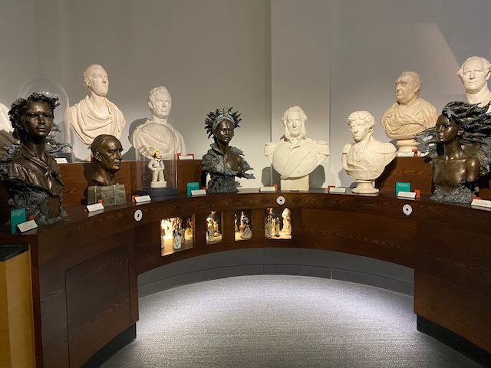
Sea Things: busts
Baltic Glass Exchange Memorial Glass
This is an open space with well-lit stained glass on either side of the space.

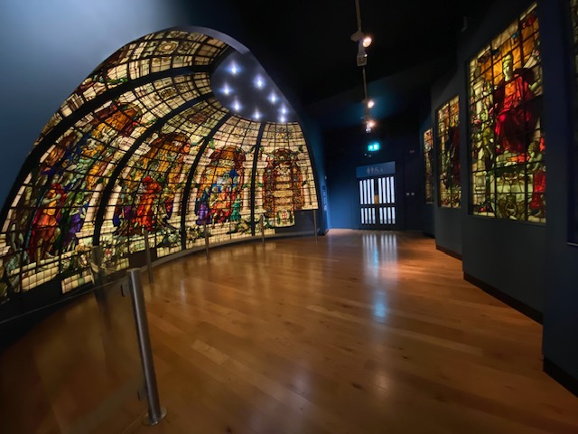

Through the doors at the south end of the gallery are toilets, including an accessible toilet.

Level 2

Tudor and Stuart Seafarers
Tudor and Stuart Seafarers has wide aisles and display cases that are visible from close to ground level. All displays and interactives are at average wheelchair user height. The interactive tables as shown above are at the height 80cm with the highest south end reaching 84cm.

In the northeast end of the gallery there is a sensory spice smelling display, as seen below. This table is at a height of 83.5cm. The gallery has automatic doors at each end of the space.

Please note that this gallery is deliberately low-lit and some visitors may find accessing the interpretation challenging. Please speak with a member of staff in the gallery if you require assistance.

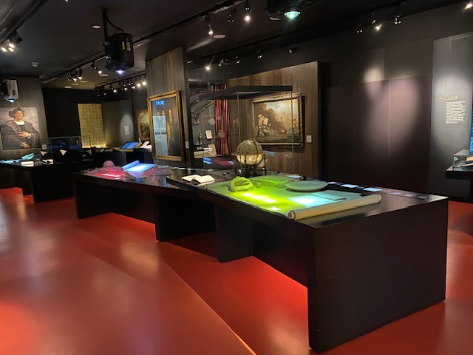
Tudor and Stuart Seafarers gallery

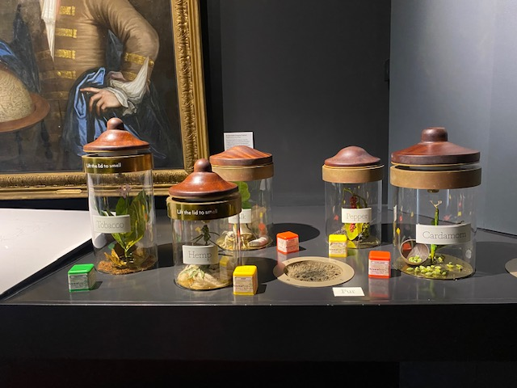
Tudor and Stuart Seafarers gallery

My Greenwich
My Greenwich is a wide-open space with a timeline of the history of Greenwich displayed. The space also has windows to look out at our lawns and the Queen’s House. There are some books about Greenwich to read here and an interactive video display. There is a floor to ceiling display of hooks for visitors to hang comments about their visit and Greenwich. There are no doors into this space.

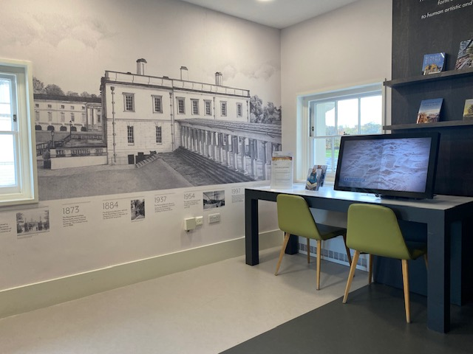
My Greenwich gallery
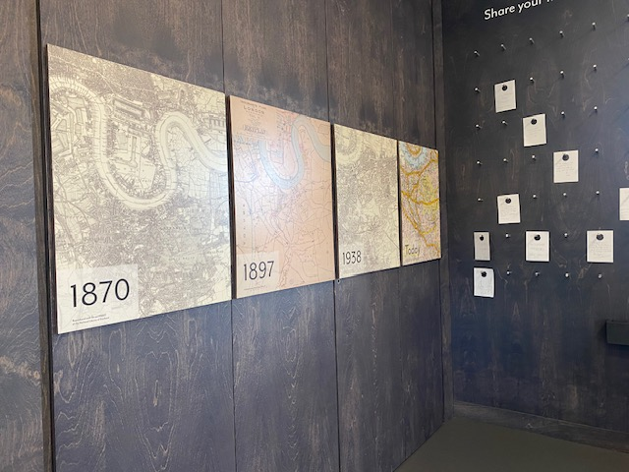
My Greenwich comment card display

Polar Worlds
Polar Worlds has lots of display cases. Some are at wheelchair user eye level, and others start from the ground level so are fully visible. Polar Worlds has automatic doors at each end of the gallery.

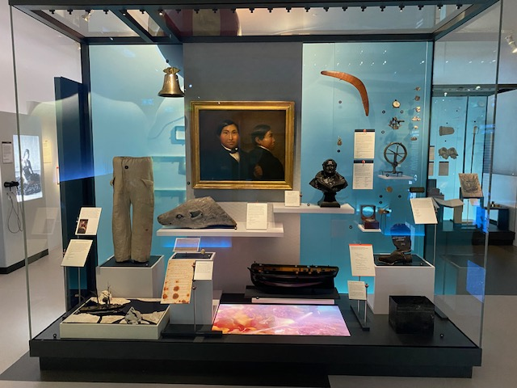
Polar Worlds gallery
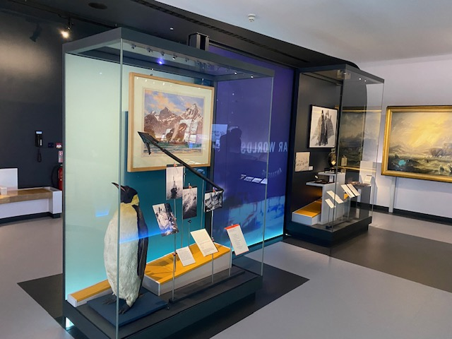
Polar Worlds gallery

Paintings and labels are displayed at a height of 60cm, and paintings around 80cm. There are several audio-visual interactives in this gallery, including a central round table. The table is slanted. At the highest end it measures 90cm, and at the lowest, 75cm.

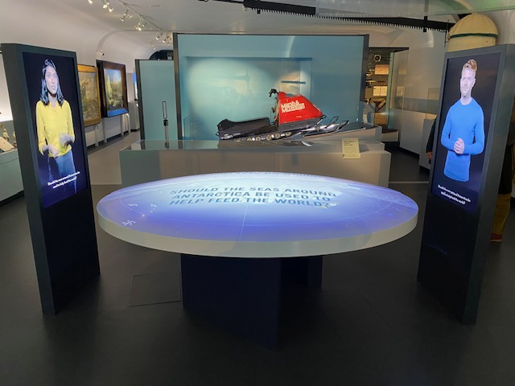
Polar Worlds gallery central table

There are interactive spaces where you are invited to try on the goggles and gloves explorers would have worn in the Antarctic. The height of each of the tables these are on is 81cm – goggles and 74cm - gloves.

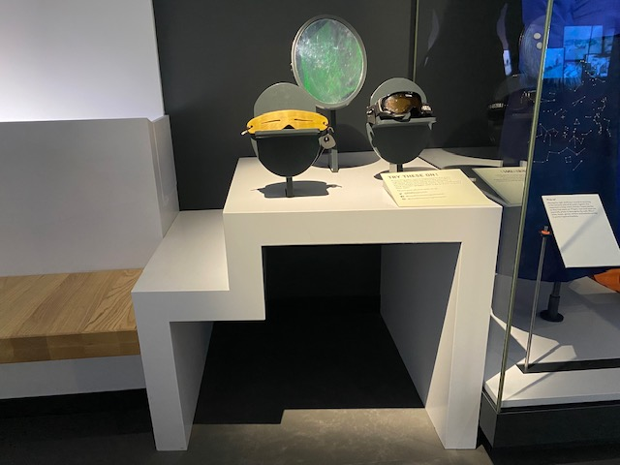
Polar Worlds gallery goggles

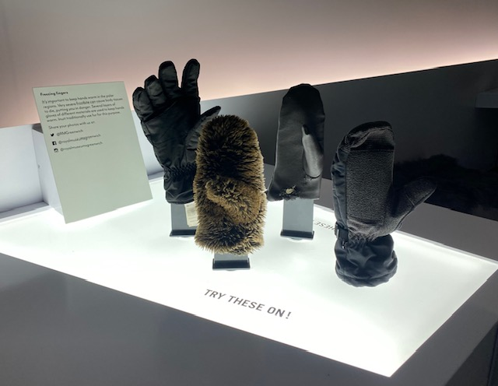
Polar Worlds gallery gloves

At the north end of the gallery, there is an audio interactive of Tanya Tagaq that requires the listener to hold an earpiece to one’s ear and push a button. The earpiece’s height is 110cm.

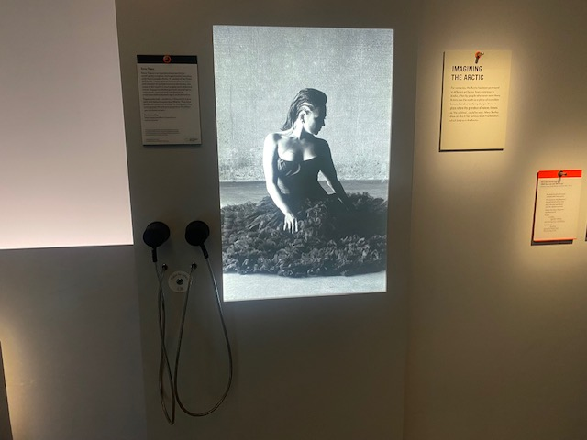
Polar Worlds audio interactive

Bridge gallery
The Bridge gallery has open fire doors at each end. They will close if the fire alarms sound. Objects are displayed at floor level. Some are interactive including a ship’s phone, which has a loud ring.

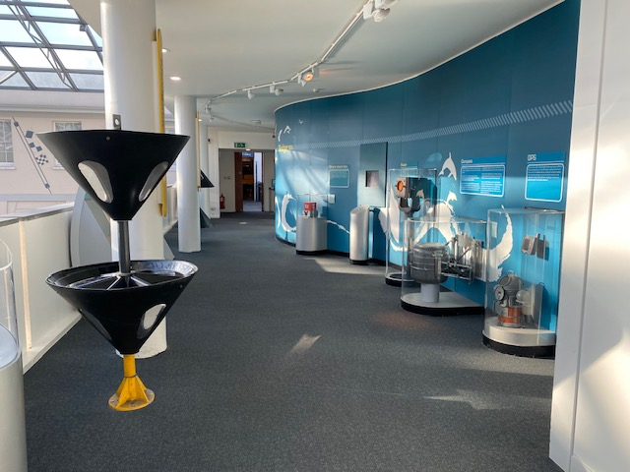
Bridge gallery
The main attraction of this gallery is the Ship Simulator, below. 63cm height from floor.

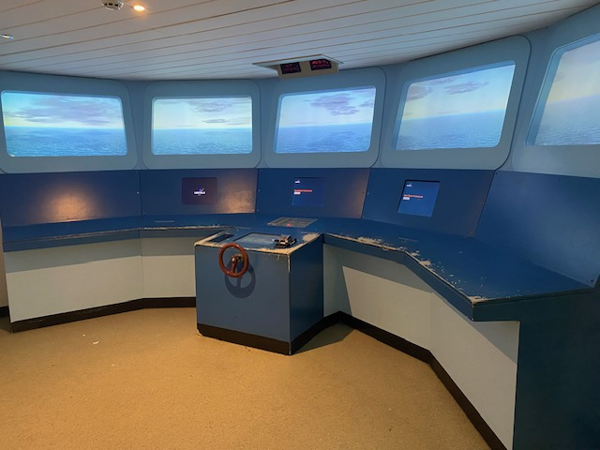
Bridge gallery ship simulator

All Hands
All Hands is an interactive children’s gallery. There is a video with audio playing constantly next to the large Cornwallis ship model, there are also morse code interactives with sound, which can be noisy for those effected by sensory overload. Ear defenders are available at The Romney admission desk. The 2 way radio and sound morse code is at a height of 70cm. A nearby display is at 74cm. A drawing table is 74cm high.

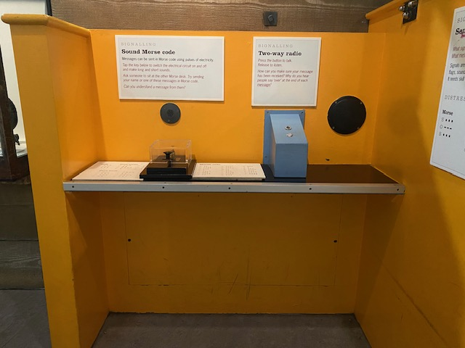
All Hands gallery morse code interactive

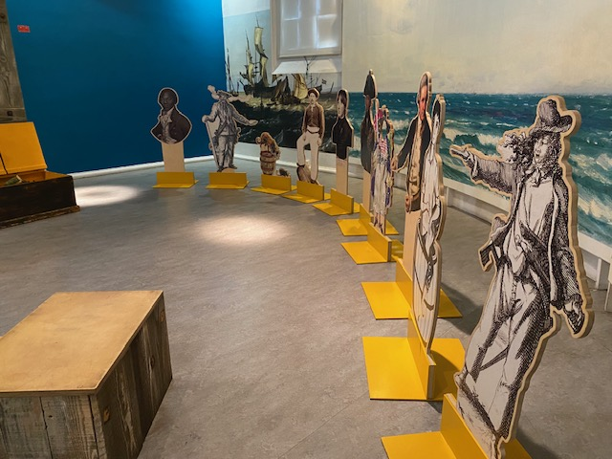
All Hands gallery – south end

The north end of the gallery has a crane interactive and a ship’s galley with replica food to play with. The ship has an audio-visual interactive inside.

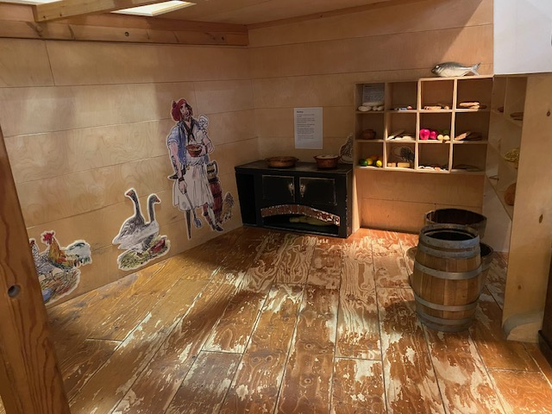
All Hands - the galley of the Seahorse

There are dress up items in trunks in the gallery and tactile objects that can be handled, such as rigging implements, a cannon, shot balls and even a cannon ball embedded in part of the mizzen mast from HMS Blenheim.
The doors at the south end of the gallery are glass and need to be opened manually before exiting. There are toilets next to All Hands gallery, including an accessible toilet and baby change facilities.

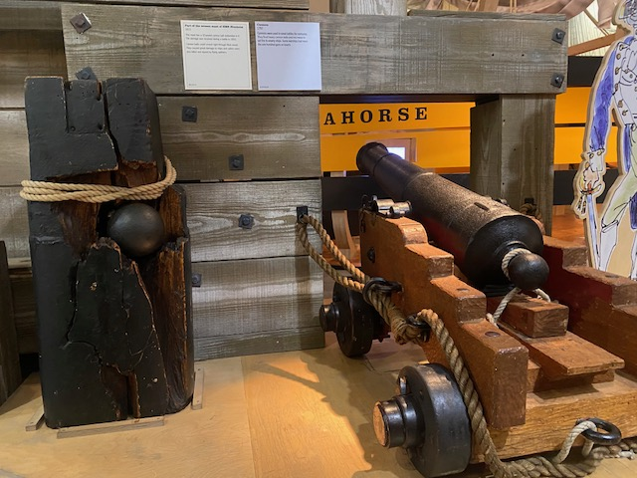
All Hands cannon from HMS Blenheim cannon ball embedded in mast.

Multi-Faith room
Also on this floor accessible, through via the Bridge gallery, is a prayer and multi-faith room. This room is open to all for prayer, meditation and reflection. Please remove shoes and respect others while using this quiet space.

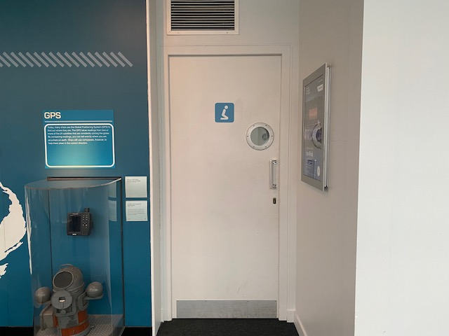
Multi-faith room entrance from Bridge gallery

Forgotten Fighters
Forgotten fighters has a wide central aisle, surrounded by interactive audio visual panels which are at a height of 73cm. These screens are attached to display cases holding ship models and artifacts from WW1. The display cases are at a height of 104cm.

There are glass doors at each end of Forgotten Fighters, which need to be opened manually.

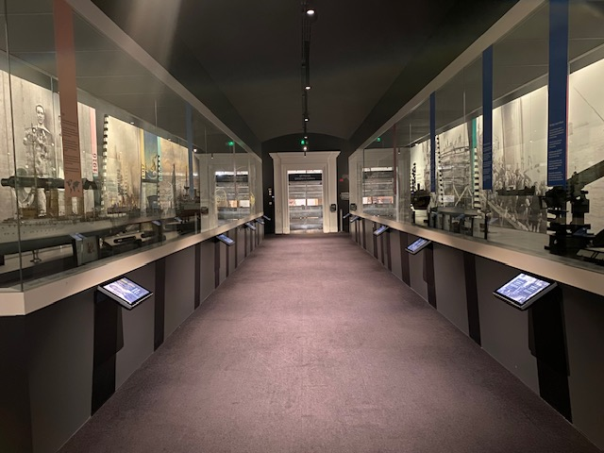
Forgotten Fighters gallery

Nelson, Navy, Nation
The main section of Nelson Navy Nation has a large aisle down the centre. Some display cases in the main gallery display are from near-floor level, others range from 50cm-76cm display height.

The main audio-visual interactive, Nelsons’s Tactics, is on a table at 73cm height, for leg room and the screen is 93cm to use.

There are 5 smaller alcoves off the main gallery. 3 of these, ‘Navy and Nation’, ‘Surgery at Sea’ and ‘The Death of Nelson’ have seating in them. ‘Navy and Nation’ has a film to watch displayed on a large screen with sound. ‘Surgery at Sea’ has loud audio, audible throughout this section with a small screen displaying BSL interpretation and subtitles. This section has a display table with a leg room height of 69cm, display 85cm.

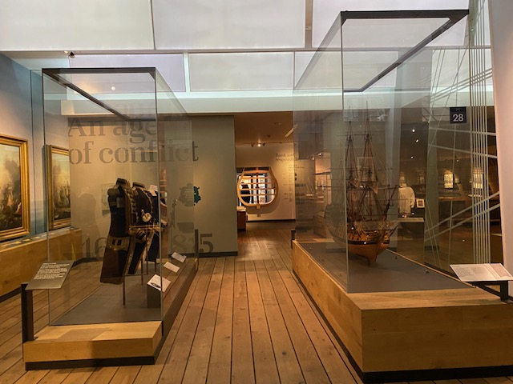
Nelson, Navy, Nation gallery

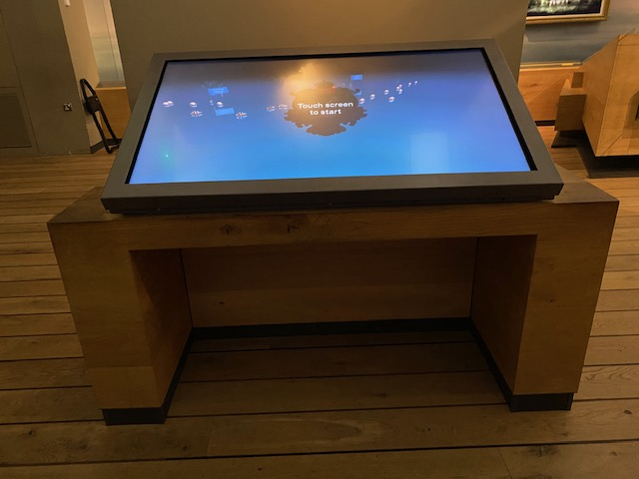
Nelson, Navy, Nation gallery interactive table

In the 5th alcove, ‘A hero mourned’, the paintings are displayed at around 100cm and the labels at 78cm from floor. At the west end of the gallery, there are several wall mounted interactive panels, called ‘Trafalgar & Beyond – Fleet’. The lowest of these are at 108cm and the highest 146cm from the floor. Running the length of the main section of the gallery is a timeline. This is 69cm from the floor. The ‘Leisure & Letters home section at the east end of the gallery is 79cm height. This features a musical audio. A separate visual element and a display case. There is a large AV interactive at the east end of the gallery. There is a tactile ship model that can be touched also at the east end.

Please be aware that a body of weapons is on display amongst the artifacts as well as images of war.

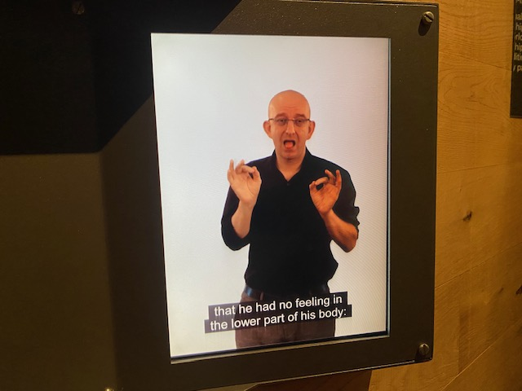
Nelson, Navy, Nation gallery video screen

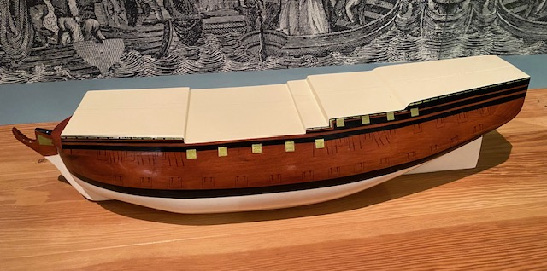
Nelson, Navy, Nation gallery ship model display

There are glass automatic doors at each end of Nelson, Navy, Nation.
Cafes
We have a café on Level 0 in the Sammy Ofer Wing, next to the Parkside entrance and a café on Level 1 next to the Great Map. Both cafés are wheelchair accessible and welcome Guide Dogs, Hearing Dogs and Assistance Dogs. There should be a bowl of water for dogs outside the Parkside Café. Please ask staff if it needs refilling.

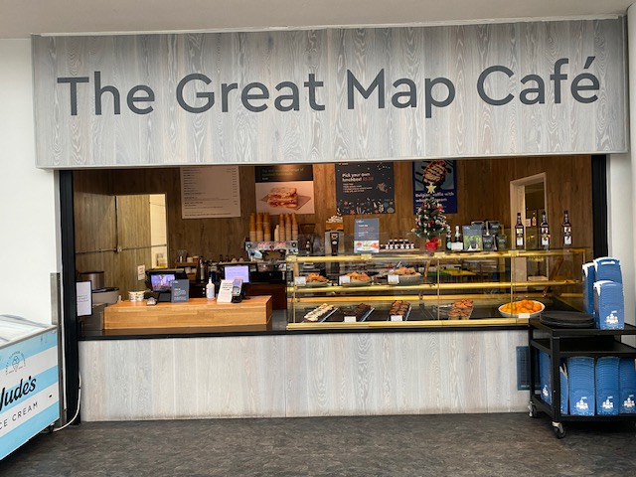
Great Map Café

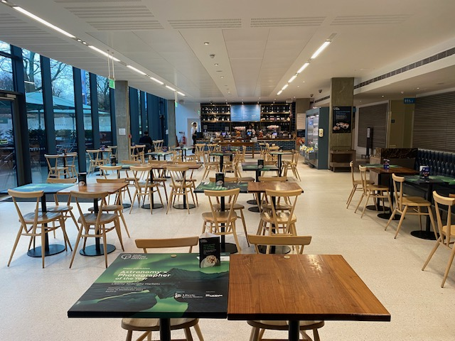
Parkside Café
Toilets
Toilets, baby-change facilities and an accessible toilet are located near the Romney Road entrance on Level 0 as well as in the Sammy Ofer Wing on Level 0, accessed via the Parkside entrance.

Additional facilities are located on Level 1 through the Baltic Exchange Memorial Glass Exhibit and on Level 2 in the All Hands gallery.

All toilet and baby change facilities are wheelchair accessible.

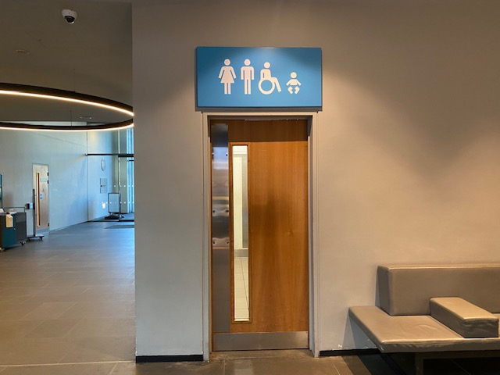
Romney Road toilet, by Romney Road Entrance

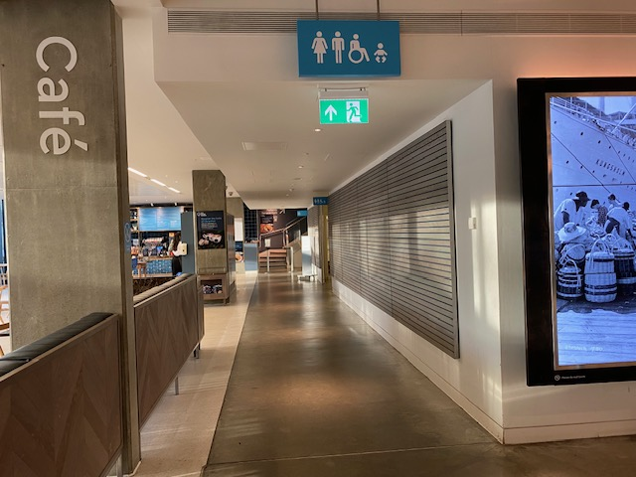
Sammy Ofer Wing toilets: access next to Parkside Cafe

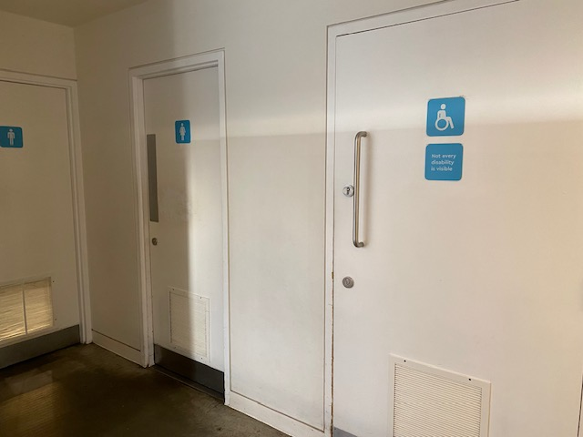
Sammy Ofer Wing toilets: entrance

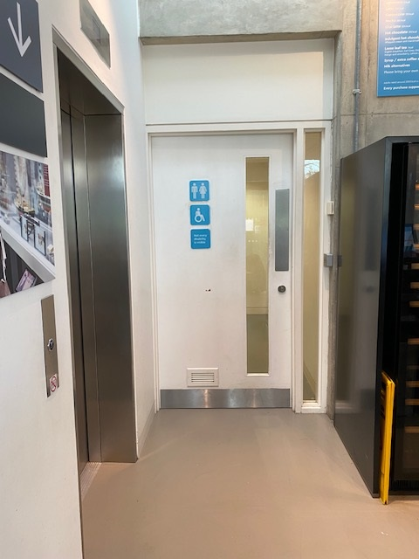

Terrace Cafe toilets: Level 1 next to the lift in the Sammy Ofer Wing

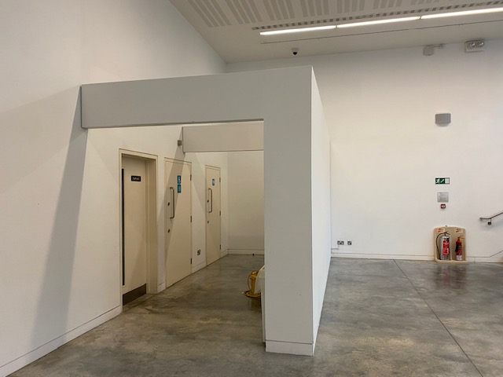

Special Exhibition toilets: Level -1 in the Sammy Ofer Wing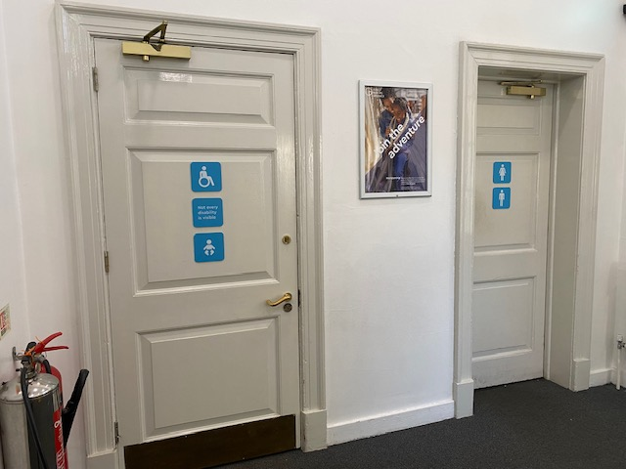

Baltic Exchange Memorial Glass Exhibit toilets: Level 1

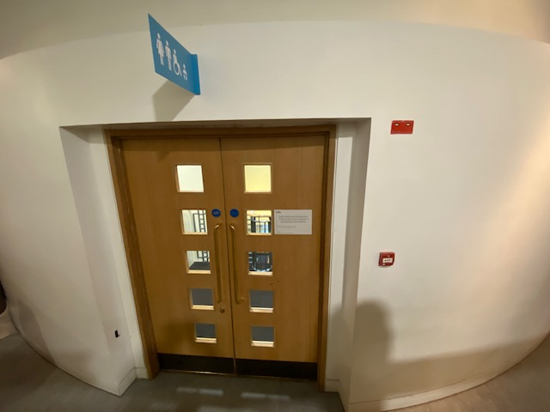
All Hands toilets: Level 2, access via these doors on the west of the gallery
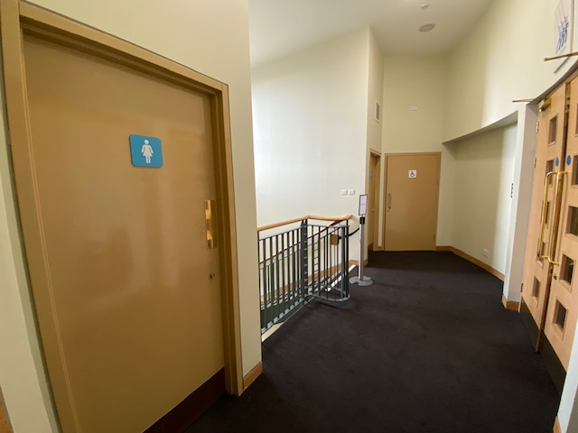
All Hands toilets: Level 2, access via these doors on the west of the gallery

Changing Places
We have a Changing Places facility available, located in the Sammy Ofer Wing. This facility is reserved for people with PMLD and other physical disabilities, so is kept locked. Please contact a member of staff if you wish to use this facility. It is equipped with a Guldmann GH2255110SG Overhead hoist, a changing table, toilet and sink.

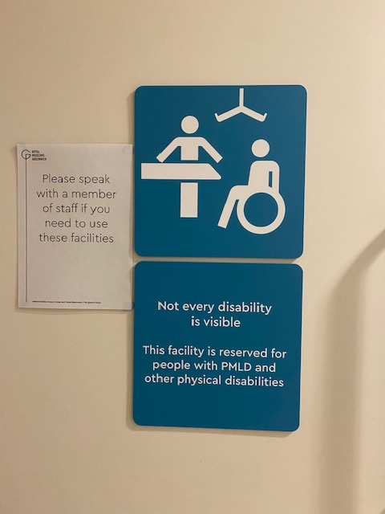
Changing Places facility: door
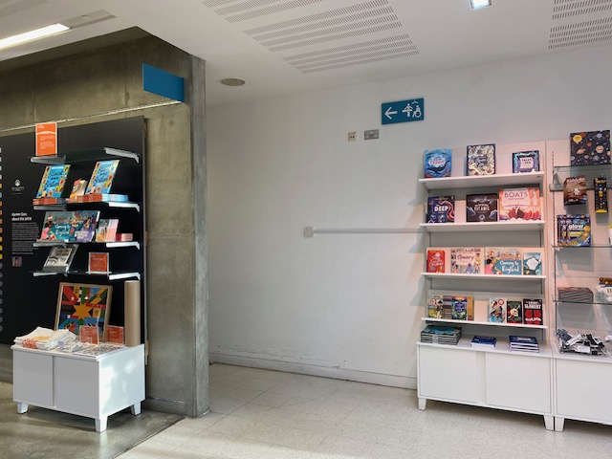
Changing Places facility: access via this corridor in the Parkside shop

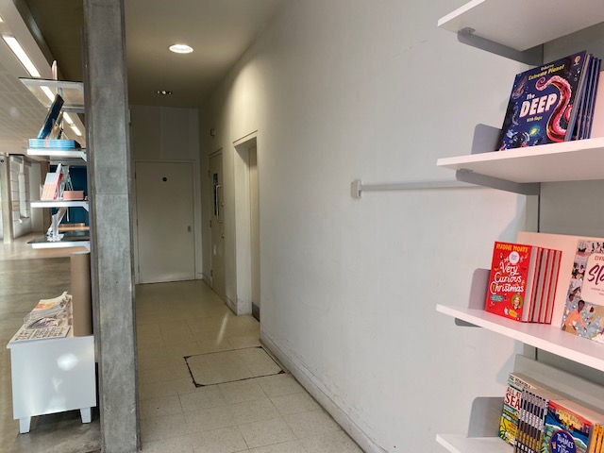
Changing Places facility: access via this corridor in the Parkside shop

Lockers and buggy park
Lockers are located on West Street, near the Propeller on Level 0. There is a small charge (£1) for their use. There is a cloakroom in the Sammy Ofer Wing for larger items, with a suggested donation of £2 per item. Please speak with the member of staff at the Parkside Information and Ticket desk to use this facility.

Free buggy parking is situated in the Sammy Ofer Wing and East Street on Level 0, on the Great Map on Level 1, and on the Bridge gallery on Level 2.
Items are left at visitors’ own risk.

Lost property
To enquire about or hand in lost property, please go to the Parkside Information and Ticket Desk. If you are retrieving an item you may be asked to provide proof of ID.

